**PARTNER**

**USER GUIDE**

**PARTNER is a social network analysis data tracking tool designed to measure and monitor collaboration among people/organizations.**

[***https://partnertool.net***](https://partnertool.net)

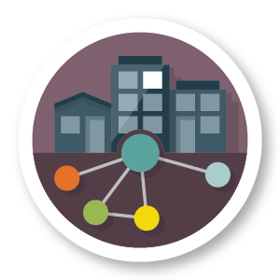

A dark room

Description generated with high confidence

**Technical Manual – PARTNER Tool**

***Updated: January 2019***



PARTNER is a registered product of Visible Network Labs. PARTNER can only be used for non-commercial purposes. For commercial applications or additional software development, please contact us at [partnertool@visiblenetworklabs.com](mailto:partnertool@visiblenetworklabs.com).

For more information about Visible Network Labs and the tools and resources available, please visit [www.visiblenetworklabs.com](http://www.visiblenetworklabs.com).

**Contact:**

Email: [partnertool@visiblenetworklabs.com](mailto:partnertool@visiblenetworklabs.com)

Address: 1536 Wynkoop Street, Suite 913

Denver, CO, 80202

Copyright © 2018 Visible Network Labs

Contents

Introduction 4

What is the PARTNER? 4

*What is the PARTNER Approach?* 6

*How can social network analysis be useful in practice?* 6

What is Network Science? 6

How Will PARTNER Help You? 8

Benefits of Using PARTNER 8

Getting Started 10

Logging into PARTNER 10

Things to Consider Before Using the PARTNER 14

Steps for Using the PARTNER Survey Builder: Start to Finish 15

*The Role of the Manager* 16

*The Role of Members of the Network* 16

Step 1: Enter Respondent Information 17

Bounding the Network 17

Uploading Respondent Information 18

Editing Respondent Information 27

Step 2: Modify Survey 30

Customize Consent Language and Instructions 30

Customize Survey 31

Step 3: Send E-mails to Respondents 44

Customize Emails 44

Step 4: Analyze Survey 54

View Data Dashboards 54

Download the PARTNER Analysis Tool 61

Download Network Analysis File 61

Communicating Results 62

Appendix 1: Glossary 64

Introduction

## What is the PARTNER?

PARTNER can track social connectedness among people and organizations. It is an easy to use, start to finish, social network data collection and analysis tool designed to measure and monitor collaboration among people/organizations. The user simply uploads a list of respondents, modifies a set of questions, and administers the survey using our online platform. Data are immediately captured and stored in an accessible database. Data dashboards and reports are available for immediate access and analysis.

PARTNER Includes:

* Online modifiable surveys, with a default survey to get you started, surveys for different topic areas, or create your own from scratch.
* An online email system to collect data, with a built in reminder system.
* A clean data set that feeds into a dashboard of visualizations and other analytics, with easy export as an excel file to import into any other visualization or statistical tool without any data cleaning
* Easy access to reports that save you hours of time and provide insight and sense-making of the data and maps.

***PARTNER Network Evaluation Framework***

The PARTNER Network Evaluation Framework was developed through research and evaluation of over 150 community networks. While the evaluation approach continues to be enhanced as our team learns from ongoing projects, the four primary areas of measurement include: Attribution, Perceptions, Agreement, and Interrelationships. These are built into all PARTNER research and evaluation designs, are foundational in the PARTNER Default Survey, and are used to guide the analysis and assessments. All four of these dimensions help us understand the network, assess the strength of the network, and provide data to inform network leadership (the process of making decision).

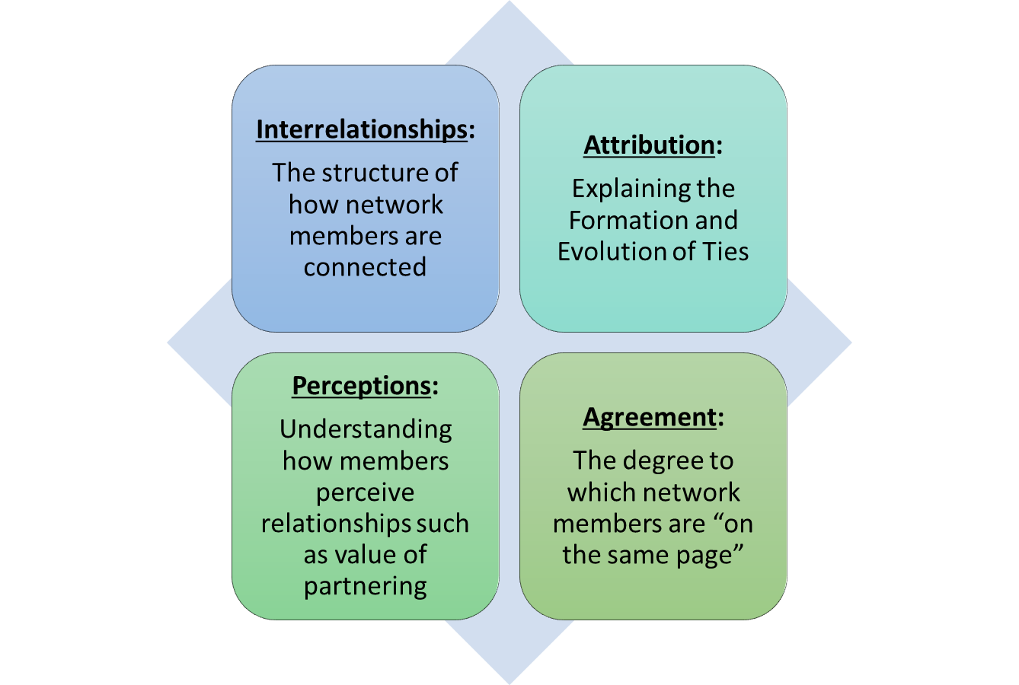

– **Interrelationships:** The actual relationships among members, including the intensity, quality, and content of the relationships tells us about the structure and strength of the network. The PARTNER Default Survey uses standard social network methodology to assess the interrelationships of the network. We can then assess how attribution, perception, and agreement are associated with the structure of the network.

– **Attribution:** Many networks are facilitated and organized by a primary organization, sometimes called a Lead Organization, a Network Administrative Organization, or a Backbone organization. Others are governed by a group of organizations. Regardless, we often want to know how the growth and development of relationships in a network are started and fostered over time. The PARTNER Default Survey (customized) can assess how the growth of relationships in a network are attributed to certain entities.

– **Perceptions:** An important piece of information for any network leader to understand are the perceptions that members hold of one another, as well as perceptions of the network itself. The PARTNER Default Survey collects data on both of these aspects. Specifically, we learn about the perceptions network members have of one another in terms of the value of the partnership (measured as power/influence, resource contribution, and time commitment) and trust (measured as mission congruence, reliability, and communication).

– **Agreement:** The extent to which members of a network agree on the way the network is functioning is a key component to network leadership. Whether the members report that the network is or is not achieving its outcomes is as important as whether or not they agree on these assessments. The degree to which a network’s members agree on these assessments is an indicator for a network leader of whether the network is functioning well or not.

## *What is the PARTNER Approach?*

Utilizing a systems approach makes the principles of social network analysis (SNA) particularly useful to measure the strength of connections in the system, evaluate how organizations are positioned within a network, to assess the quality and impact of the exchanges among them and to identify where resources can strengthen the network. In addition, network visualizations can be displayed to illustrate partners and the links between them. From a science perspective, SNA provides a mathematical approach to measure the connections between members of a network, as a tool to indicate patterns. When this science is translated into practice, community-based networks of cross-sector partners can use the data for evidence-based strategies and action steps, and to document progress over time. PARTNER is a social network analysis tool used in over 2500 communities in all 50 states and over 40 countries, to help networks identify needs, leverage resources efficiently, evaluate the strength (and gaps) among member relationships, and ensure that networks have the capacity to address the needs of their community.

## *How can social network analysis be useful in practice?*

Bringing cross-sector partners together to create coordinated, efficient networks is widely accepted today as best practice in system-building efforts. In addition, funders are requiring evidence of collaboration before awarding and providing funds for program activity. Yet, there is a shortage of guidance on how to do so without further overburdening an already stressed system. The idea that successful networks must increase the number of partners and meetings can overwhelm the effort. Alternatively, identifying measures of partnership that include looking at the quality of relationships, the exchange between member organizations, and various options for “networking” can help networks manage relationship budgets (i.e., the time and resources spent managing relationships in order to achieve the collaborative’s goals).

## What is Network Science?

***What is a network?***

A network is any interconnected group or system. For the purposes of this technical manual, networks refer to a formal partnership created between three or more people or organizations to achieve mutually desired objectives. Networks of organizations working across sectors to tackle big social problems are one approach to achieve social impact.

***A network science lens.***

Network science provides theories and methods that can be used to guide the study and practice of working in networks. Intuitively, we know the kind of connectivity that is good, and that which is not. However, very few people know how to manage these processes, or leverage them in any kind of strategic way that may actually result in better connectivity. We learn at an early age that more connectivity is better – the more friends we have, the more popular we are; the more people we know, the more likely we are to succeed professionally. However, network science (the science of the interconnectedness among human and organizational entities) is based on a definitive principle that **more is not always better**.

So how can we leverage the power of networks, while working within the reality of resource scare environments? While the appeal to create a more diverse network is strong, we are equally challenged with the reality that we have **limited relationship budgets** – that is, limited resources to build and manage diverse networks. We know that networks have advantages but there is a limit on how many relationships we can manage before we lose the collaborative advantage altogether. We simply cannot exponentially grow networks without incurring costs attributed to that approach.

Network science can provide the theories and methods that together provide an evidence-based approach to building network approaches that are based on data and lead to strategies, actions and interventions. Social network analysis (SNA), which is the study of the structural relationships among interacting network members — individuals, organizations, etc. — and of how those relationships produce varying effects – is a tool that provides unique data to inform these practices.

***How can information/data about networks be used in practice?***

Using SNA to understand how a network functions can help network leaders, members, funders and other stakeholders identify ways to continuously improve how they work with one another to achieve common goals. The information can help plan and implement relationship building and resource leveraging among network members, assess the quality, content, and outcomes of partnerships, monitor change in networks over time, and develop strategies and action steps to fill gaps and leverage strengths in networks.

How Will PARTNER Help You?

The results from PARTNER will help your network strategically plan ways to work together in order to address social and public health issues facing your community. PARTNER is intended to help members identify strategies for improving their networks while staying within their relationship budgets. By systematically measuring connectivity (or the number and quality of relationships) over time, networks can better understand how resource expenditures are linked to collaboration, thereby providing better accountability to each other and funders.

## Benefits of Using PARTNER

PARTNER offers many benefits for measuring your network including:

1) **Score your network.** A set of indicators (scores) help users to identify baseline measures of progress, areas where improvement can be made, and potentially even progress over time.

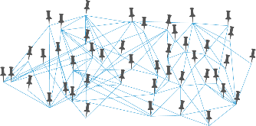

2) **Visualize your network**. In addition to scores, visualizations of your network can be a powerful representation for you and your partner organizations regarding how connected you truly are, where gaps exist among relationships, and how you might allocate or shift resources to strengthen particular relationships.

3) **Share results with network members, funders, and other stakeholders**. Results can be easily shared with members of your network in addition to others such as community stakeholders and funders. By assessing scores and visualizations of your network activity, you can demonstrate the functionality of your network. For existing funders, these results highlight where and how funding has been used to strengthen partnerships. For potential new funders, a tool like this can concretely show where resources should be allocated to maximize collective benefit.

***Example***

Consider the example of childhood obesity: Suppose that the public health department, along with a group of interested stakeholder organizations has a goal to reduce childhood obesity by ensuring that more children are screened for associated health risk factors (level of physical activity, access to nutritious meals in school). To achieve this goal, the network has attempted to create new and diverse connections throughout the community to work collectively to achieve the goal. However, after getting results from implementing the PARTNER Survey, it is determined that partnerships with the local school district and Department of Parks and Recreation could be improved (e.g., these relationships exhibit low trust). Given the collaborative’s goals; it uses these findings to spend more time improving relationships with those members of the collaborative. The network can then track how changes in these relationships are associated with improvements in these risk factors (e.g., developing plans with Parks and Recreation for more safe play areas; working with schools to offer healthy meal options in the school cafeteria).

This visualization and explanation illustrate what your network analysis might look like in your data dashboard:

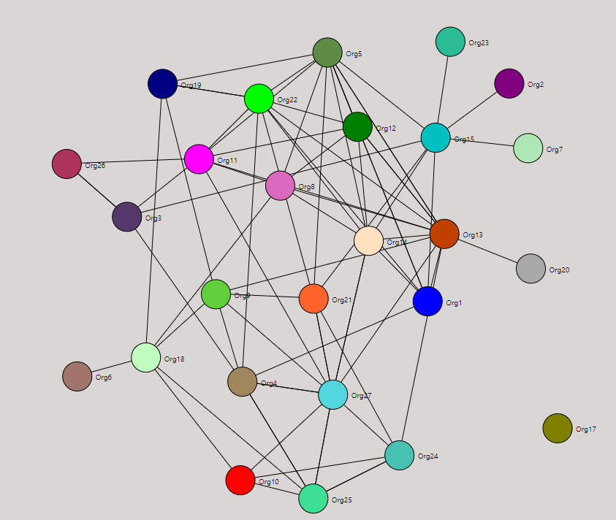

In addition to finding out more about the quality of connections in the network, PARTNER provides network maps of connections in the data dashboards. The visualizations represent who is connected to whom at various levels of interaction, the value of organizations for different characteristics, and the types of resources that each organization brings to the network. These network maps can be used to increase awareness and understanding of how network members interact with one another.

Getting Started

## Logging into PARTNER

|  |
| --- |
| First thing you will you need to do is register. Go here to register as a new user: <https://partner.visiblenetworklabs.com/users/>. You will be sent a message asking you to verify your email by clicking on a link. Once your email is verified, you can log in to the PARTNER Platform.  **Already a PARTNER Manager?** We have moved to a new e-mail based login, so you will need to register here the first time that you use this new platform. Inside, you can link all of your projects by verifying any e-mail address that you ever used in the system. |
|  |
| Once you are registered and logged in, we encourage you to update your user profile under the Project Manager: Your Projects. Your Surveys, Surveys You Were Invited To and People/Orgs in Your Network(s) will update automatically under Your Projects when you add email addresses associated with your PARTNER logins in the past.  *At a minimum you will need to add any additional emails associated with your PARTNER data. This will allow you to access and analyze all of your data with a single login!* |
|  |
| Once you have updated all your email addresses associated with your PARTNER accounts, the Your PARTNER Organizations and Your PARTNER Networks sections will automatically fill in with the data associated. If an organization or network is not listed, please email [partnertool@visiblenetworklabs.com](mailto:partnertool@visiblenetworklabs.com) to troubleshoot. |
|  |
|  |

|  |
| --- |
| Getting to Survey Builder Home Page  From the PARTNER Platform home screen, you can get the Survey Builder Home Page 2 ways. 1) Go through Project Manager or 2) Go Through Survey Builder. |
|  |
| We recommend managing your projects and surveys through Project Manager. When you log in to PARTNER, click on “**Open Project Manager**”. The listing of the surveys in your account is listed here. Click “**Go to Project**” for the project you want to work on within the Survey Builder/App. |
|  |
| For the second option, this time when you log in to PARTNER, click on “**Go to Survey Builder Tool**” button which will take you to the Survey Builder Home Page. |
| A box will pop up asking if you want to connect to the Survey Builder as a respondent or a manager. Select “**Manager**” and click “**OK**”. |
| Select the network you want to work with in the Survey Builder and click “**OK**”. |
| Now you are on the home page for the Survey Builder where you can manage and set up your entire project from start to finish including uploading your respondent information, customizing your survey, administering your survey, and analyzing your network data. |

## Things to Consider Before Using the PARTNER

* **Sharing Findings**. Once you analyze findings from using PARTNER, you will need to consider the best way to share those results with members of your network, accounting for potential data sensitivities. For example, PARTNER may highlight particular discrepancies in how two organizations may view their relationships. Thus, you may want to frame the presentation of specific findings in a way that respects those relationships and will not impede the progress of your network. You may also consider using coded identifiers as the “short names” in your network maps to maintain privacy of your respondents.
* **Adhering to Procedures for Ethical Conduct of Research**. Before administering the PARTNER Survey Builder, ensure that you are following any guidelines regarding study conduct via your Institutional Review Board or other research review protocols. Namely, you want to be clear about guidelines pertaining to data confidentiality and identifiability of responses before embarking on this process.
* **Ensuring the Accuracy of Information**. As described earlier, PARTNER relies on the full participation of all members of your network for the best and most

accurate analysis of your network activity. Consider ways to engage members in this process early on in order to obtain comprehensive information on your network.



# Steps for Using the PARTNER Survey Builder: Start to Finish

Using PARTNER requires some primary steps: Add Members, Define Metrics, Collecting Data, Map and Analyzing Results, and Create a Report. In the next few sections, we will cover these steps in more detail.

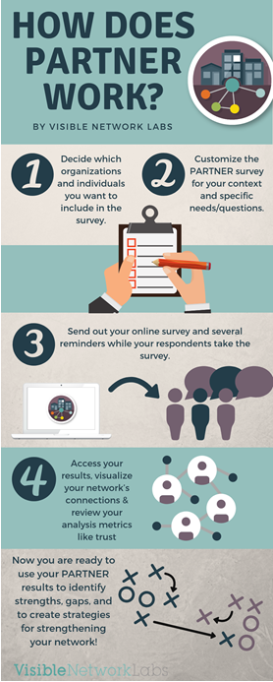**Add Members**

1. Identify the members of the network to include in your list
2. Enter respondent information online

**Define Metrics**

1. Customize the survey for dissemination

**Collect Data**

1. Send survey introduction, invitation, and reminders to respondents
2. Have respondents take the survey

**Map and Analyzing Results**

1. Analyze results, including generation of network scores and visualizations; repeat analysis as appropriate.

**Create a Report**

1. Inform chosen stakeholders of findings, including, for instance, network partners, existing and potential funders, and/or other community members.

## *The Role of the Manager*

The manager will take the lead role in coordinating the network partners to take the survey, administering the survey, and completing the analysis. The manager can be a member of the network or an outside person who is willing to take on this responsibility. The manager will need to have basic knowledge in two general areas:

1. A list of members of the network with contact information for each.
2. Knowledge of how to work with Microsoft Excel to save files, enable macros, copy and paste data, and work between worksheets.

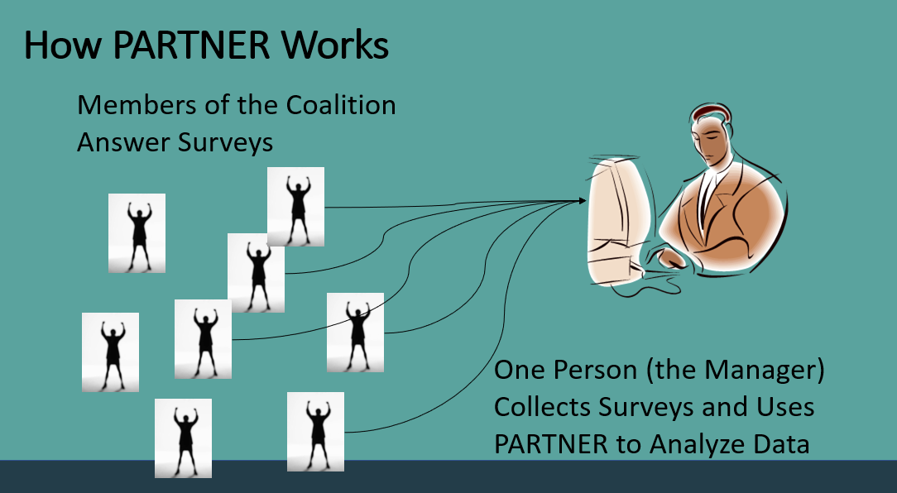

Primary tasks of the manager will be to:

* identify network partners
* prepare and customize the survey
* customize survey emails (intro, invite, and reminder)
* produce network maps
* generate network scores
* analyze outcomes
* disseminate results of analysis

## *The Role of Members of the Network*

Members of the network (comprising mostly of, but not limited to organizations) will be contacted by the manager to complete the online survey. It is vital that as many members of the network participate in this exercise in order to obtain a comprehensive analysis of how the system is functioning. However, if some members do not participate, the analysis can still be performed.

# Step 1: Add Members

|  |  |  |
| --- | --- | --- |
| This is the point in the process where you enter all the information of the members of your network you wish to include in the survey. In order to do this, you first want to identify which organizations (or individuals if appropriate) are members of the network you want to analyze. It is necessary that you “bound” the roster of organizations involved in the network you wish to evaluate before you will be able to use the Survey Builder. If your organization plays a role in the network be sure to include it in the list if you want your organization be to a part of the results. For some, this is one of the hardest steps in the project. Some may know exactly who they will include in their respondent list and others may find this step to be more challenging. Bounding the Network The organizations, agencies, departments, programs, and initiatives you choose to include as you bound your network will be the entities that will show up in the network maps representing the system in your community or state, and the specific contacts at each organization will be the ones who are responding to the survey answering on behalf of their organization. Because of this, it is critical that the process of bounding your network be both *collaborative* and *intentional*. The process is *collaborative* because you, the manager of this survey, should reach out to the key members of your network and ask them which organizations they consider to be part of the system in your community. Next, think about who is not currently considered part of the system but maybe could or should be involved. If there is a backbone organization, it is important to seek input from them on their organizational partners as a first step because they have a “view of the landscape” that other organizations may not have. The process is also *intentional* because you will want to be purposeful in who you include in the final list of organizations and respondents.  You will want to include specific contacts who have “sat at the table” and can answer the survey which includes questions around the network itself, as well as questions about the specific partnerships their organizations maintain with other organizations in the network. There may be some organizations for whom you do not already have an established contact possessing the high-level perspective needed to participate in this project on behalf of their organization. Should cases like this arise, seek input from your partners on the best-suited individual from those organizations to participate.  Be sure to include representation from all sectors that work in that topic area in your community or state. Consider including in this project any and all organizational partners that are working together on the collective goal of the network. For example, public health networks often include not only health care providers, insurers, purchasers, public health departments, community-based organizations, but also entities that operate outside the traditional sphere of health care, such as faith-based and other non-health community-based organizations, schools, businesses, and even other non-health governmental agencies.  *Tip: If you are not sure who to include, take a pause to get feedback from stakeholders or key informants in the system. Ask them who they would include and work with the list they produce. Engaging them in this process will ensure you have a comprehensive list, but also begins to develop buy-in from your partners when you engage them in the process.*  Once you have determined which organizations (and/or departments or individuals) you will include in the survey process, you will enter all respondents’ information online. Uploading Respondent Information Once you have signed into PARTNER, clicked on “**Go to Survey Builder**”, select the network you want to work with, and you will be taken to Survey Builder Home page of that network. This page contains Steps 1 through 4, links to your account settings and profile, and links to other networks you are managing under your account.  The first step in using the Survey Builder is to load information about the respondents you want to survey. You have two options for loading respondent information.   1. You can upload respondent information as a batch. 2. You can load respondents in one-by-one. | | |
| ***Loading Respondent Information as a Batch***  Downloading the Respondent Information Worksheet is the quickest way to enter your respondent information because it enables you to enter all respondent information in one place, and then upload it to the Survey Builder with a few simple clicks.  You can access a link to download the Respondent Information Worksheet in all three links under Step 1- Enter Respondent (Network Members) Information on the Survey Builder home page. You can download the worksheet right from the Survey Builder home page by clicking “**Download Respondent Information Worksheet**”, there is also a link under “**Load Respondent Information**” and there is also a link under “**Edit Respondent Information**”. | | |
|  | | |
| When you download the Respondent Information Worksheet and open it, the first thing you will need to do is “**Enable Content**”. Depending on your computer’s security settings the first thing you may have to do is “**Enable Editing**” before you can “**Enable Content**”.  *Note: This worksheet does not usually work with Macs, only PCs will correctly upload the worksheet.  This is how the worksheet appears: | | |
|  | | |
| ***Completing Your Respondent Information Worksheet***  Now that you have determined which organizations you will include in the survey and you have downloaded the template, you will then fill it out with your respondent list. **At a minimum, you will need to include at least a long org name, short org name, group, username, last name, first name, email and password (Columns A-G & O).**  Address, city, state/region, country, zip/postal code, phone, organization sector, and primary org function are not required to send a survey but will be required to access certain functionality coming soon in our Dashboards. For example, GIS mapping is a feature coming soon and that requires an address from each organization.  **Listing Organizations and Short Names (Column A and B).** If multiple people from an organization are members of the network, choose one person who will best represent that organization to include as the survey respondent. DO NOT duplicate organization names (long names or short names). If you have more than one contact within the same organization or more than one person from the same entity, you will need to distinguish their organization name so that respondents to the survey will can make a distinction between them on a list. An option is to list an organization and include different programs/departments within the organization as different entries.  Think about if the multiple contacts represent the organization the SAME way at the table to other network partners or if they represent the organization in UNIQUE ways at the table. It is also important to note that each organization listed becomes its own node in the network maps. For example, Hospital A has two contacts at the table, one represents Emergency Services and one represents Administration. Those contacts are representing the Hospital in unique ways and should show up as separate nodes for Hospital A because network partners connect to them differently. If the contacts are representing the Hospital in the same way at the table, then the hospital should only be one node in the network maps because partners connect to those contacts the same.  The short name should be as concise as possible to make the network graph legible (approximately 2-5 characters). Should it better serve your purposes, you may want to discretely code these short names in order to maintain anonymity of the respondents in the network maps. Alternatively, you may prefer to utilize established and well-known acronyms for the various organizations, so they may be easily recognizable in the map visuals included in your report.  *Tip: Do not include multiple people from the same organization, but rather have them work together to answer the survey. If you do include multiple contacts from the same organization, you will need to add a department or a title at the end of the organization name and short name because the PARTNER Tool will not accept redundant names (e.g., Child Learning Center-Director (Short name- CLC:D) and Child Learning Center: Teacher (CLC:T)).*  **First Name, Last Name and Email (Column E, F, and G).** You will need to provide a name and email address for each contact who will receive the survey on behalf of that organization.  *Tip: You can include your name and email address for organizations you want to include in the list but either do not have a contact for that organization or that contact/organization does not know enough about the network to fully answer the whole survey.*  **Group (Column C).** You need to assign each organization/individual to a “group”. You can have up to 13 groups maximum, used to identify a “characteristic” or “attribute” for each organization/individual. The group type should be chosen based on what makes sense to each network. For example, you can define groups based on type of agency (e.g. health care, faith based, business), a workgroup or type of role in the network (e.g. outreach committee, data committee), or even by another characteristic like size of budget (e.g. low, medium, high). To define groups, decide on group categories and then type the group type name for each organization/individual in the “Group” column on the respondent list that you will upload online.  **Username and Password (Columns D and P).** Usernames and passwords are created by the manager and entered into the respondent sheet. The respondent usernames must be unique identifiers (there are over 3,500 respondents and/or managers in the system) so we suggest managers be creative when assigning user names. You can use the acronym for the network or project, followed by a number. We also recommend that managers use the same password for their whole respondent list, although you can select different passwords for each.  **Address Fields and Phone Number (Columns H, I, J, K, L and O).** Address, country, city, state/region (abbreviation 5 characters max, country, zip/postal code and phone are not required to send a survey but will be required to access certain functionality coming soon in our Dashboards, like GIS mapping. You will be able to add this information later if you do not wish to include it initially.  **Organization Sector (Column M).** You can assign a sector to each organization by clicking on the cell and selecting an option from the dropdown. The options are: Public, Private, and Nonprofit. Organization Sector is not required to send a survey but will be required to access certain functionality coming soon in our Dashboards.  **Primary Organization Function (Column N).** You can assign a primary organization function to each organization by clicking on the cell and selecting an option from the dropdown. Primary Organization Function is not required to send a survey but will be required to access certain functionality coming soon in our Dashboards, like comparing data across all networks by attributes like this. The options are: | | |
| * Animal-related * Arts, Culture & Humanities * Civil/Human Rights, Social Action & Community Improvement * Consulting/Evaluation * Crime & Legal-Related * Disaster Preparedness & Relief * Don’t Know/Unsure * Do not want to specify * Economic Development * Education * Employment * Environment * Faith-Based * Financial | * Food, Agriculture & Nutrition * Foundation/ Philanthropy * Government * Health * Housing & Shelter * Human & Social Services * Insurance Provider * International-Related * Library * Manufacturer * Media & Communications * Mental Health & Crisis Intervention * Military & Veterans Organizations | * Other * Policy/Advocacy * Professional Societies & Associations * Public Safety * Real Estate * Recreation & Sports * Research & Data Analytics * Science & Technology * Service, Hospitality, & Retail Industry * Transportation * Tribal * Utility Services * Volunteerism * Youth Development |
| Once you enter all your respondent information in this worksheet (be sure to make your list as accurate as possible before uploading) you are ready to upload it. Although you can edit respondent information once uploaded, you cannot remove or edit a *username* once created. Once you have filled out the worksheet, click the “**Export to PARTNER Format**” button within the spreadsheet. | | |
|  | | |
| Then select which folder you want to save the file to, change the name of the file (if you want) and then click “**Save**”.  A popup box will appear and let you know that the file was saved and where it was saved. Click “**OK**” to dismiss this box. | | |
| Once you have saved the text file go back to the Survey Builder home screen. Under Step 1, click the button that says, “**Load Respondent Information**” (see below). Then simply click “**Browse for your respondent file**” (see below), browse to your saved text file and click “**Open**” (see image on next page). | | |
|  | | |
|  | | |
|  | | |
| After you click “**Open**” you will be taken to back to the previous screen to review your list before you officially add them to the Survey Builder (scroll down past the buttons). If you see any errors just hit the back button in your browser, fix the errors in the excel file, resave and upload the updated file.  *Note, you are able to edit your respondent information after it has been uploaded.    If you get the error message “Validation failed: usernames already exist” or “Validation failed: orgs already exist”. You must choose new usernames or org names and try again before you can upload the file. Click the back button in your browser, fix the errors in the excel file, resave, and upload the updated file. Other common errors include duplicate organization short names or missing information from one of the required columns | | |
|  | | |
| ***Loading Respondent Information One by One***  You can aslo load in your respondents, one by one. Under Step 1 on the Survey Builder home screen click on “**Edit Respondent Information**”. (see below). | | |
|  | | |
| Next, click on “**Add Respondent**” (see below). | | |
|  | | |
| From there you will fill out the information for each individual respondent and click “**Save**” at the bottom. You will only be allowed to click on the “Save” button once you have entered in all the required fields (indicated by a *). | | |
|  | | |
| Once your respondents are uploaded, the Survey Builder will produce an automated notification that you have invitations pending (illustrated below). This message is simply an indication that you’ve uploaded your respondents. **You should not send your invitations until you’ve completed Step 2 Modify Survey, which is covered in the following section**. | | |
|  | | |
| Editing Respondent Information You can edit the information that was loaded in for each respondent. Under Step 1, click on the button that says ”**Edit Respondent Information**” from the Survey Builder home screen. | | |
|  | | |
| Then click on “**Edit**”. | | |
|  | | |
| Then select the respondent(s) you would like to edit or delete. Then click either “Edit Respondent(s)” or “Delete Respondent(s)”. | | |
|  | | |
| Make your changes to the respondent’s information and then click “Save” or “Save and next” if you choose mulilple respondents to edit | | |
|  | | |
| If you selected respondents and then clicked “Delete Respondent(s)”, a popup box will appear give you a warning that any and all data linked with those selected will be deleted. Click “Ok” if you want to delete the selected respondent(s) and click “Cancel” to go back. | | |
| You should only send the survey invite to launch the survey once you have a final and correct list of respondents uploaded. **You should not send your invitations until you’ve completed Step 2 Modify Survey, which is covered in the following section**. | | |

# 

# Step 2: Modify Survey

|  |  |  |  |
| --- | --- | --- | --- |
| Customizing your survey is a necessary step in the process unless you want to use the PARTNER Default Survey (with any modifications). Under Step 2 Modify Survey you have the following options: Customize Consent Language and Instructions; Select a survey to use and customize; and Check Response Rate. | | | |
|  | | | |
| Customize Consent Language and Instructions Click “Customize Consent Language and Instructions” toprepare the text that respondents will have to accept before they can begin the survey. This is the text that your survey respondents will read after login and before entering the survey. | | | |
|  | | | |
| Under “Consent Text” there is some generic default language that we have created, this is where you’d type any consent language that your organization recommends or if you are satisfied with the default language, you can leave it as it is. We recommend that you edit the language under “Survey Background and Instructions” to give your respondents a little more background on your project and edit the instructions as necessary for your group. Click “Save” once you have made your edits. If you want to preview your edits, click on “Customize Survey” under Step 2 and then click on “Preview Survey”. | | | |
|  | | | |
| Customize Survey Under Step 2 Modify Survey, you will see a dropdown under **Select Survey to Use** where you can choose the survey template that is best for you. You can use the PARTNER Default Survey, one of the 10 Topical Surveys, create your own survey from scratch or copy from a previous survey you may have prepared for another project. | | | |
| Topical Survey Options:   * Anchor Network * Early Childhood Network * ER Preparedness, Recovery, Response Network * HIV Provider Network * Informal Health System | | | * Social Determinants of Health * Service Provider Network * University-Community Partnership * Veteran Suicide Prevention Network * Youth Violence Prevention Network |
|  | | | |
|  | | | |
| Once you have selected a survey template to work with, click “Customize Survey”. | | | |
| ***PARTNER Default Survey***  From [www.partnertool.net](http://www.partnertool.net) click on “[Resources](https://visiblenetworklabs.com/partner-tool-resources/)” under Tools on the menu. Here you can download an Excel spreadsheet or Word document that contain all of the PARTNER Default Survey questions. As a note: If you want to use the legacy PARTNER tool in Excel or measure Trust and Value you **must use** the PARTNER Default Survey. If you are not wanting to use the legacy tool or measure Trust/Value, the restrictions within the example files here on how the Default Survey questions can or cannot be modified do not apply to your survey. | | | |
|  | | | |
|  | | | |
| Once you have downloaded the spreadsheet or document of the PARTNER Default Survey questions, you can modify the questions in preparation for changing them online. Go through each survey question and make changes to the question text, question type, or response options according to the needs of your project. When you select the PARTNER Default Survey in the dropdown under Step 2 and click “**Customize Survey**” the default survey will load into your account so you can make any modification to the survey online.    In the PARTNER Default Survey, Questions #1-9 are the “non-relational” questions that ask respondents about the network as a whole. Questions #10 -#18 are the “relational” questions that ask respondents about their specific partnerships with other members of the network. The word document: PARTNER Default Survey to Modify has additional options you can use as relational questions.  *PLEASE NOTE: this Excel file/Word Document is for planning purposes only (not for uploading), once you’ve customized your survey, you will have to type (or copy and paste) any changes to questions and responses into the survey customization screens in the PARTNER Survey Builder under Modify Survey.* | | | |
| ***Create Your Own Survey***  To start with a blank survey, select Create Your Own in the dropdown under Step 2 and click “**Customize Survey**”. You be taken to a screen where you can build your survey from scratch. | | | |
| The first step in creating your own survey is to begin adding questions. Click “**Add Question**”. | | | |
| Before the system will allow you to “**Save**” the question, you must include text for the question, or you will get a message that says: “UNSAVED Question not saved: question text cannot be empty”.  You will also need to change the Question Type to something other than “Open Ended”, add question text, “**Save**” the question and then you get the ability to add response options. | | | |
| ***Adding Response Options to Questions***  Click “**Add/Edit Response**” to add response options. You have four options that will show up in a popup box. Once you make your selection of how you want to add responses click “OK”. | | | |
| * Copy responses from another question * Use answers from another question * List one response at a time * List all responses at a time | |  | |
| **Copy responses from another question:** Easily copy responses used for another question into the question you are currently editing. You can only use this option ONCE you have at least one question that includes responses. Select the question you want to pull response from in the dropdown and click “**OK**” and those response options will automatically get pulled in to the question you are currently editing. | |  | |
| **Use answers from another question:** This is similar to the PARTNER Default Survey Questions 5 and 7 where the answers respondents chose in another question are used as the response options for the current question. You can only use this option ONCE you have at least one multiple choice question that respondents have selected answers. Select the question you want to pull response from in the dropdown and click “**OK**” and those response options will automatically get pulled in to the question you are currently editing. | |  | |
|  | | | |
| **List one response at a time:** You will choose this option for longer response options when your response takes up more than one line in the uploader (see image to the right). Once you have inserted your response click “**OK**”. | |  | |
| **List all responses at a time:** Easily add all response options at one time. Just put each new response on its own line. If your response option is longer than one line you will need to choose the option above. Once you have inserted all your responses on separate lines click “**OK**”. | |  | |
| Once you add response options you can drag to reorder, edit, or delete the response option. | | | |
| * **To reorder:** Simply click and hold the text of the response option, then drag text to the new location and let go of the mouse. * **To edit** **responses:** Click on the icon next to the text (look like a pad and pencil). Make your changes and then click “OK”. * **To delete responses:** Click on the trash can icon and then click “**OK**” when asked if you want to process with this decision. | |  | |
| ***Editing Questions***  Similarly, you can you can drag to reorder, copy, or delete questions with the survey. | | | |
| * **To reorder questions:** Simply click and hold the six dots at the top of the question box, then drag question to the new location and let go of the mouse. * **To copy a question:** Click on the copy icon on bottom right within the question box located next to the trash can icon. A new duplicate question will automatically be added to the end of your survey. * **To** **delete a question:** Click on the little trash can icon on the bottom right within the question box located next to the copy question icon. You will need to click “OK” when asked if you want to process with this decision. If you delete a question, there is no way to recover it, so be sure you want to delete before proceeding. | | | |
| ***Question Type Options***  *You can add either a non-relational question or a relational question to the survey. N*on-relational questions ask respondents are general questions usually about the network as a whole. Relational questions ask respondents about their specific partnerships with other members of the network. | | | |
| The non-relational question types available include:   * Open Ended * Single Choice * Multiple Choice * Pick Your Organization | The relational question types available include:   * Network Member Selection * Relation/Single Choice * Relational/Multiple Choice | | |
|  | | | |
| **Open Ended:** An open-ended question is designed to encourage a full, meaningful answer encouraging the respondent to type in their response instead of selecting their response from a list of pre-determined options. This question type is non-relational.  **Single Choice:** A single choice question asks respondents to pick only one answer, from a pre-determined set of responses of at least two or more options. This question type is non-relational.  **Multiple Choice:** A multiple choice question asks respondents to pick as many answers as applies, from a pre-determined set of responses of at least two or more options. This question type is non-relational.  **Pick Your Organization:** This question allows respondents to select their organization from the list. You will not need to include this question in your survey. This question is only used for the PARTNER Default Survey as question 1.  **Network Member Selection:** This question type allows respondents to select from the list of organizations uploaded in respondent worksheet. This corresponds to Question 10 in the PARTNER Default Survey. **Before you can ask any relational questions, you must ask this Network Member Selection question first. You can only ask this question type one time in your survey.**  **Relational Single Choice:** A relational single choice question asks respondents to pick only one answer, from a pre-determined set of responses of at least two or more options in relation to the partners they chose in the Network Member Selection question. This question type is relational and asks respondents to answer about their specific partnerships with other members of the network  **Relational Multiple Choice:** A multiple choice question asks respondents to pick as many answers as applies, from a pre-determined set of responses of at least two or more options in relation to the partners they chose in the Network Member Selection question. This question type is relational and asks respondents to answer about their specific partnerships with other members of the network  *NOTE: You cannot ask an open-ended relational question, nor can you add an open-ended response to a single or multiple choice question, i.e. Other, Please Explain.* | | | |
| ***Preview Survey***  You can preview the survey as a respondent by clicking on “**Preview Survey**” on the top of the page within the survey editor. This will take you to the Instructions and Consent page of your survey. Click “**Begin Survey**” to begin the survey preview. | | | |
| You can exit the survey preview by clicking on “Save and Exit” or “Submit Survey” . Or if you are on the last question in the preview click “Finish” then “Exit Preview Survey”. | | | |
| *NOTE: If you have a question that uses answers from another question it will show all response options in the preview area. If you pilot this survey you will see how it pulls answers from the other answered question.* | | | |
| ***Print Friendly View***  If you would like to print a final version of your survey or send a respondent a paper version of the survey click the button “**Print Friendly View**”. | | | |
|  | | | |
|  | | | |
| You can remove the header and footer from the webpage by clicking “**Toggle Header/Footer**”. From this page go to your settings and click on “**Print**” or click “**Ctrl+P**”. | | | |
|  | | | |
| *NOTE: If you have already inserted your respondent list, the organizations from the respondent list show up in print friendly view.*  *-If you want to a print a survey showing questions and responses only, print the survey BEFORE uploading respondents.*  *-If you need to send this survey to a respondent as a paper version, be sure to upload your respondent BEFORE you print. You need the respondent list to show up in the paper survey.*  Relational questions show up with all organizations from the respondent list unless no respondent list has been uploaded yet.  *NOTE: You will need to instruct those taking the paper survey to not answer about their own organization in regard to the relational questions. In the online survey respondents are not shown their own organization in the list of organizations to choose as a partner because your organization cannot be a partner with itself in network analysis (the organization is represented as one node in the network map). You can also cross out that organization’s row from the relational questions before sending the paper survey to the respondent.* | | | |
|  | | | |
| Once you have modified your survey and uploaded your respondent list you are ready to launch your survey. See Step 3 Sending Emails. | | | |

# Step 3: Send E-mails to Respondents

|  |  |  |
| --- | --- | --- |
| You can choose to send you survey introduction, invitation, and reminder emails from the PARTNER Platform.* Under Step 3 Send Emails to Respondents you have the following options: Customize Emails and Send Emails.  *If you would rather you can send the information via your own email system and we can work with you to create the login link that respondents will need to use to take the survey. | | |
|  | | |
| Customize Emails Click “**Customize Emails**” toprepare the email templates that you will use when you send your emails. You can add and save as many email templates as you need. This is especially helpful if you are sending multiple surveys to different networks under the same login. Within the Customize Emails section you can either create a new template or pull up a previously saved template to work on. | | |
| ***Create a New Email Template***  To create a new email template, click on “**Customize Emails**” and start filling in the information for your email, including: Template Name, E-mail Subject, and E-mail Body.  You can add the following syntaxes in email message to personalize your messages including:   * %user – username of the respondent * %FirstName – first name of the respondent * %LastName – last name of the respondent * %OrgName – full name of the organization that the respondent belongs to * %NetworkName – full name of the collaborative that the respondent’s organization belongs to * %pw_reset_url – URL for the respondent to reset their PARTNER password * %login_url - URL that will allow the respondent to log in without entering a username or password   If you started to fill in information and need to reset the template, scroll up and click on “**New Email Template**”. Then click “**OK**”, which then will reset it a blank template.  *NOTE: There is not a way to include a password syntax for reminder or introduction emails. The password is included with the default invitation text, but not include any where else. To include the password for each respondent, we recommend you give all respondents the same password so you can include it in the email body text.* | | |
|  | | |
|  | | |
| Once you have added your information click “**Save**”. Click “**Save As**” if you go make any changes to that template and want to save it as new template with a different name. | | |
| ***Editing an Email Template***  To edit a previously saved email template, click “**Customize Emails**” and click the dropdown under Email Template Name. Select the template you want to edit and begin your edits. | | |
| Once you have edited your information click “**Save**”. Click “**Save As**” if you go make any changes to that template and want to save it as new template with a different name. | | |
| ***Default Invitation Text***  The default invitation text is available for all survey invitations sent through PARTNER. You do not have the ability to edit this text. But you do have option to select whether you would like to include this text in your invitation email. This text includes information on the organization they have been requested to participate on behalf of, their username and password, and a specialized login link for that specific respondent. If you choose to disable the default invitation text in your message, be sure to include the syntax: %login_url which provides a link to allow the respondent to log in without entering a username or password.  *NOTE: You will make the selection to enable or disable the default invitation text when you send your invitation email. This selection does not take place when customizing emails.* | | |
|  | | |
| Sending Emails Click “**Send Emails**” tosend introduction, invitation, or reminder emails to respondents. A date will display indicting when the first email was sent. If no email has been sent yet, it will say Unsent. You can only send an email once you have saved an email template. If you have not yet saved a template, click “Customize Emails”.  *NOTE: You can only send invitations ONE time. However, if you need to send an invitation to a respondent whose email was incorrect or missing, you can send those respondents a “reminder email” using your invitation saved email template. Just be sure to only select the respondents who did not receive the original invitation email. You will not be able to include the default invitation text, but you can recreate it with syntaxes and just inserting the password in the message. Use the syntax: %login_url which provides a link to allow the respondent to log in without entering a username or password.* | | |
| ***Sending Introduction Emails***  Click on “**Send Emails**” and then click on “**Send Introductory E-mail**”. | | |
|  | | |
| Select the template you want to use in the dropdown under Select an e-mail template to use. | | |
|  | | |
| Select which respondent(s) you want to send this email. Select respondents one by one or click “**Select all**” to select all respondents. Click “**Unselect all**” to deselect all respondents. | | |
|  | | |
| If you need to make any final edits to your message, make those in the Email Subject or Email Body fields. (If you do make any edits, the system will require you to save the changes under the current template or save those changes under a new template. **Be sure to CC yourself on sent messages!** This way you can easily forward a message to a respondent who said they did not receive it.  When you are ready to send your message to respondent, click “Send E-Mail”. | | |
|  | | |
| You will get a little message above the “Send Email” button that says “Messages sent!” confirming that your email was sent. |  | |
| ***Sending Invitation Email***  Click on “**Send Emails**” and then click on “**Send Invitation E-mail**”. | | |
|  | | |
| Select the template you want to use in the dropdown under Select an e-mail template to use. | | |
|  | | |
| Select which respondent(s) you want to send this email. Select respondents one by one or click “**Select all**” to select all respondents. Click “**Unselect all**” to deselect all respondents. | | |
|  | | |
| The default invitation text is available for all survey invitations sent through PARTNER. Select or deselect the checkbox next to “Include default text” under the Default Text heading.  You do not have the ability to edit this text. This text includes information on the organization respondents have been requested to participate on behalf of, respondent’s username and password, and a specialized login link for that specific respondent. If you choose to disable the default invitation text in your message, be sure to include the syntax: %login_url in the email body which provides a link to allow the respondent to log in without entering a username or password. | | |
|  | | |
| If you need to make any final edits to your message, make those in the Email Subject or Email Body fields. (If you do make any edits, the system will require you to save the changes under the current template or save those changes under a new template. **Be sure to CC yourself on sent messages!** This way you can easily forward a message to a respondent who said they did not receive it. When you are ready to send your message to respondent, click “Send E-Mail”. | | |
|  | | |
| You will get a new screen with a message that says “Messages sent!” confirming that your email was sent and that there are no pending invitation for this network. | | |
|  | | |
| ***Sending Reminder Emails***  Click on “**Send Emails**” and then click on “**Send Reminder E-mail**”. | | |
|  | | |
| Select the template you want to use in the dropdown under Select an e-mail template to use. | | |
|  | | |
| Select which respondent(s) you want to send this email. Select respondents one by one or click “**Select all**” to select all respondents. Click “**Unselect all**” to deselect all respondents. Since you are sending reminder emails you will only be able to select those who have not submitted their survey.  *NOTE: Even if a respondent submits their survey, they can still log in and make edits or add more to their survey. However, you as the manager can longer send them reminder emails once they have submitted a survey. If you must send this type of respondent an email, you can send them an “introduction” email and select the reminder email to use for the message.* | | |
|  | | |
| If you need to make any final edits to your message, make those in the Email Subject or Email Body fields. (If you do make any edits, the system will require you to save the changes under the current template or save those changes under a new template. **Be sure to CC yourself on sent messages!** This way you can easily forward a message to a respondent who said they did not receive it. When you are ready to send your message to respondent, click “Send E-Mail”. | | |
|  | | |
| You will get a new screen with a message that says “Messages sent!” confirming that your email was sent and that there are no pending invitation for this network. | |  |
| You can send multiple reminders to respondents through PARTNER. We typically follow a specific email schedule for our projects. Learn more in the next section. | | |
| ***Email Schedule***  For the projects we work on, we typically use the following schedule:    We send the introduction email on a Friday and follow that up with the invitation email on a Monday saying the survey will close after two business weeks. Then over the course of those weeks we send a series of a few reminder emails. On the survey close date, we send a survey extension email saying “You’re in luck, the survey deadline has been extended by one week!”.  We then send two more reminder emails that third week and make a final decision on whether to keep the survey open based on the response rate. If we feel the response rate is still too low, we may do personalized follow up phone calls with respondents who have not submitted their survey.  *NOTE: The survey never officially closes, and you can download your data and or analyze it in the Data Dashboards at any point after you have launched your survey. We do recommend that you give respondents a deadline so they’ll complete it in time, if you’d like to tell them it will close by a certain date that is okay.* | | |

# Step 4: Analyze Survey

|  |
| --- |
| You can choose to analyze your survey by viewing your data in the Data Dashboards, Download the PARTNER Analysis Tool (legacy tool and can only be used if you modified the PARTNER Default Survey), and download network analysis file. |
|  |
| View Data Dashboards Click “**View Data Dashboards**” toanalyze your data in the Data Dashboard area of PARTNER. |
|  |
| Select a question from dropdown under “Pick which question you want to visualize/analyze.”  ***Analyzing and Visualizing Non-Relational Questions***  If you select a non-relational, open-ended question your data will be displayed as table. |
|  |
| If you select a non-relational, single choice or multiple choice question your data will be displayed as a chart. You can choose how you want to see the data for these types of questions. Options include: Bar chart, Column chart, and Pie chart. |
|  |
| ***Analyzing and Visualizing Relational Questions***  If you select a relational, single choice or multiple choice question your data can only be displayed as a network map. You can choose at what level you would like to see the data for these types of questions. Options include showing “At least” or “Exactly”.  Choose to view “At least” if you have your relational question set as a likert scale (ordinal)-which allow response options that are in a specific valued order (e.g. smallest to largest) and respondents can only select one answer. If you wanted those who interact “at least” once a year on the map, all those who chose “Every Day” would also appear on the map because they interact at the least once a year (they just happened to interact more often).  Choose to view “Exactly” when you want to view the respondent who “exactly” chose that response. In this case if you wanted to see those who only interact once a year, you would use the “exactly” option in analysis. You will view your data at this level if your relational question is not set as a scale or where respondents can select more than one answer. |
|  |
| ***Visualizing Network Maps***  You have a few options in how you want to display network maps. |
|  |
| **Color Nodes By:** This option allows you to change the color of node by the groupings used in the respondent list (Group column, Org Function column, and Org Sector column).  **Size Nodes By:** This option allows you to change the size of the nodes based on a network score. Options include: Degree Centrality, In-Degree, Out-Degree. You can also size by overall Trust and Value if you used the PARTNER Default Survey.  **Force:** This option allows you to change the size of the network map (nodes closer or farther apart) by using the slider.  **Node Size:** This option allows you to change the size of the node by using the slider.  **Label Size:** This option allows you to change the size of the node labels by using the slider.    **Click Node for Ego Map:** This option allows you to enable or disable the ability to see an organization’s ego map by click on the node in the network map.  **Click Node for Details:** This option allows you to enable or disable node level details from showing when you click on a node in the network map. See image below. This option will not work if you also have “Click Node for Ego Map” also selected.    **Show Isolates:** This option allows you to enable or disable isolates from showing in network maps. An isolate is a node that is not connect any other node.  **Show Label:** This option allows you to enable or disable node labels from showing in network maps. This is helpful if you need to deidentify your network maps. |
| ***Layered Network Maps***  You can layer response options from non-relational single choice or multiple choice questions on to the network maps. Select a question from dropdown under “Visualize who picked which response.” This gives you a selection of all available choices. |
|  |
| Once you select a question, you have the ability to choose which response option to use in the network map. Select your response choice in the dropdown under “Pick which response option you want to use.” This gives you a selection of all available choices. |
|  |
| Once you have chosen a response option to use, your network map will update indicating who chose that response option with a striped node. See image below. |
|  |
| In the network map example above, the lines between the nodes indicates those who connect with their partners at least once a year or less. The color of the node indicates the sector each organization was grouped by in the respondent list. And the nodes that are striped indicate that respondent answered that they thought the network was “successful” at meeting its goals. |
| ***Analyzing and Network Scores***  Within PARTNER you have the ability to analyze individual and whole network scores. |
|  |
| ***Individual Network Scores***  Click on “**Individual** **Scores**” to see network scores for each individual organization such as Degree Centrality, In-Degree Centrality or Out-Degree Centrality. If you use the PARTNER Default Survey, you will also get an overall value score, power/influence score, score, resource contribution score, overall trust score, reliability score, mission congruence score, and open to discussion score for each respondent.  **Degree Centrality:** The percentage of connections that a node has out of 100%. A 100% indicates an organization is connected to every other organization in the network and is central within the network.  **In-Degree Centrality:** The number of organizations who chose that organization as a partner. (The number of times this organization is chosen as a tail).    **Out-Degree Centrality:** The number of other organizations an organization selected as a partner. (The number of times this organization is a head).  **Overall value score:** An average of the ranking given by all other members for that organization along three dimensions of value: power/influence, level of involvement, and resource contribution on a scale of 1-4. Definitions for these dimensions of value can be found in the PARTNER Default Survey.  **Overall Trust Score:** An average of the ranking given by all other members for that organization along three dimensions of trust: reliability, support of mission, and open to discussion on a scale of 1-4. Definitions for these dimensions of trust can be found in the PARTNER Default Survey. |
|  |
| ***Whole Network Scores***  Click on “**Network** **Scores**” to see the whole network score for Response Rate and Density. If you use the PARTNER Default Survey, you will also get an overall value score and an overall trust score. Degree Centralization is coming soon! |
|  |
| **Density:** This score represents the number of connections reported between organizations. Density is presented as a percentage to describe the proportion of connections that were reported, in relation to all possible connections. For instance, the Sandbox Data density score is 11.54% which means that only 11.54% of all possible connections between organizations were reported by respondents. This means that there is a lot of opportunity in this network to develop connections between participating organizations.  **Whole Network Value Score:** The percentage of how much members value one another along three dimensions of value: power/influence, level of involvement, and resource contribution. . A 100% occurs when all members value others at the highest level. Definitions for these dimensions of value can be found in the PARTNER Default Survey.  **Whole Network Trust Score:** The percentage of how much members trust one another along three dimensions of trust: reliability, support of mission, and open to discussion. A 100% occurs when all members trust others at the highest level. Definitions for these dimensions of trust can be found in the PARTNER Default Survey. |
| Download the PARTNER Analysis Tool Click “**Download the PARTNER Analysis Tool”** toanalyze your data in the PARTNER legacy Tool. The PARTNER Tool is programmed in excel and can only be used if you modified and used the PARTNER Default Survey. Please see our previous technical manual for specific instructions on how to use the PARTNER Legacy Tool. |
| Download Network Analysis File Click “**Download Network Analysis File”** todownload your data as a csv file. Within that file, data is differentiated in multiple sheets by relational and non-relational data. |

# Communicating Results

|  |
| --- |
| **Inform Chosen Stakeholders of Findings**  Once you have completed your analysis, you will likely want to share findings with members of your network, existing and potential funders, and other community stakeholders. Your analysis will yield information on network scores as well as network visualizations. This information can be inserted into a report, a briefing, or other type of presentation on the progress and activities of your collaborative. Please note that you can print many of the pages with network visualizations or network scores directly from the screen. In addition, you may want to export the visualizations into other applications using a screenshot. You can also see our technical manual and demo video on the Report Builder (coming soon!).  You can also order a full report of your data from the PARTNER team (cost: $675). Neat and concise report with all your data including Quality Improvement questions following each section. This report will summarize all of your data into a word document. You will have to customize the report when you get it with details from your own project. This option allows you to spend your time diving right into your results without having to spend the hours and work putting the data into a report. Once you get the report you can use the QI questions and start to think strategically about your data. You can also purchase a 2-4 page report of your data in a highlights document (cost: $325).  **Members of Your Network**  Your network partners will likely be interested in how your network has been functioning, where there are gaps in the relationships, and how communication can be improved. As described earlier, you will want to respect any potential sensitivities in sharing particular data on relationships between particular organizations. However, sharing overall network scores (e.g., connectivity, density) can describe whether you are working together in a way that will help achieve your stated goals. In addition, a network visualization can show members which organizations are collectively identified as central to the network. These data can aid the network to reflect on whether having these organizations as central or core to the network is actually strategically appropriate for achieving the public health goal.  For example, let’s return to our example of childhood obesity described earlier. Suppose that you are a relatively new network that would like to address the issue of childhood obesity in your community by targeting key risk factors that include reduced physical activity and access to healthy foods. However, your analyses reveal a trust score that is particularly low. In addition, the network visualization shows that the schools, Department of Parks and Recreation, and grocery stores are not well connected to the health department and other organizations working on childhood obesity. Thus, you may want to use the trust score and the visualization as a rationale for spending your next year building and strengthening relationships, particularly with those isolated organizations that are key to your stated goals. In addition, these data may help you problem solve with partner organizations to identify why trust may be low. In addition, it may help to inform how working relationships with these organizations can be improved to address your goal of increasing child physical activity and access to healthier meal options.  **Existing and Potential Funders**  The network scores and maps also can provide important information for funders, both existing and new. For example, if you have a multi-year grant from a funder, you may want to conduct the survey at key time points over the course of the grant (before the grant begins, at one point during, and at the end of the grant). This longitudinal data can show funders how the collaborative relationships have improved over time, how strengthened relationships can be linked to better health indicators in the community, and where efficiency in working relationships has been streamlined. Using a network map, you also can show a potential funder where their funding could help strengthen a particular set of relationships to improve health in the community.  **Other Community Stakeholders**  Community leaders also may be interested in the activities of the network, particularly when strengthened relationships and new partnerships can be linked to improved community health. In addition, a network map presented in a community forum or other venue, can show community leaders who is involved in addressing a particular issue.  Let’s return again to our example of childhood obesity. Suppose the analyses have helped your network improve particular relationships, and now the health department has connected with local business leaders to increase access to healthier food options. By explaining this new relationship, community stakeholders may be able to offer ideas on how to build on this health department-business partnership to address other related health issues. In addition, the findings can be a powerful advocacy tool for community leaders (e.g., church, government) to take to their constituents to show where partnerships can be beneficial. |

## Appendix 1: Glossary

**Central members**: Network members who hold key positions in the network because of the number and placement of their connections within the whole network.

**Centralization:** A measure of the extent to which a network is dominated by one or a few very central hubs (i.e., nodes with high degree and betweeness centrality). In a highly centralized network, these central hubs represent single points of failure which, if removed or damaged, quickly fragments the network into unconnected sub-networks. A less centralized network has fewer points of failure and exhibits greater resilience, since many nodes or links can fail while allowing the remaining nodes to still reach each other over other network paths.

**Collaborative:** A formal or semi-permanent partnership created between three or more people or organizations in order to better achieve mutually desired objectives.

**Connectivity:** The state of being connected between two or more points in a network.

**Density:** The concentration of individuals who are connected to each other in a network. An increase in connections means an increase in density.

**Embedded:** The nature by which a network member is contained within the relationships   
of others.

**Frequency of contact:** The number of occurrences of being in touch with another person, group, or organization during a certain time period.

**Network:** Any interconnected group or system.

**Network Map:** A visualization to display the members of a group and the relationships among them. Nodes (usually represented as circles) represent the members of the network and the presence of a line connecting any two nodes represents the presence of a relationship.

**Reciprocity:** The mutual exchange between people, organizations, or groups.

**Redundancy:** Repetitive or a duplication.

**Relationship budgeting:** Making discriminate choices between collaboration alternatives, considering the cost, quality, and possible outcomes of a strategic approach to collaborative management. The primary question driving a relationship budget is: How many relationships can effectively be managed with the resources available and still achieve the outcomes we desire?

**Resource Exchange:** A mutual sharing and receiving of goods, knowledge, experience, etc.

**Score:** A number indicating quality or performance.

**Social Network Analysis:** The study of the structural relationships among interacting network members — individuals, organizations, etc.—and of how those relationships produce varying effects. The fundamental property of network analysis is the ability to determine, through mathematical algorithms, whether network members are connected—and to what degree —to one another in terms of a variety of relationships like communication, resource sharing, or knowledge exchanges. Network analysis provides a mathematical approach to measure the number, the paths, and the strength of those connections. In addition, visual representations of the network can be created as graphs.

**Trust:** Measured here as the amount of reliability, support for the mission, and willingness to engage in frank, open, and civil discussion, considering a variety of viewpoints that an organization is described as having.

**Value:** The weight placed on an organization in terms of its ability to provide resources, the level of power/influence it has in the community, and the level of involvement it contributes to the group. Each of the three characteristics are considered equally important, however the more any single organization/person has of each improves the way the organization/person is valued overall.

**Visualization:** A graphic or pictorial representation to communicate a message.

**Workbook:** A collection of two or more worksheets which will make up a book of worksheets.

**Worksheet:** An extension of many columns and rows creating a grid of cells which can hold data.

For More Information Contact:

PARTNER

partnertool@visiblenetworklabs.com

Copyright © 2018 Visible Network Labs